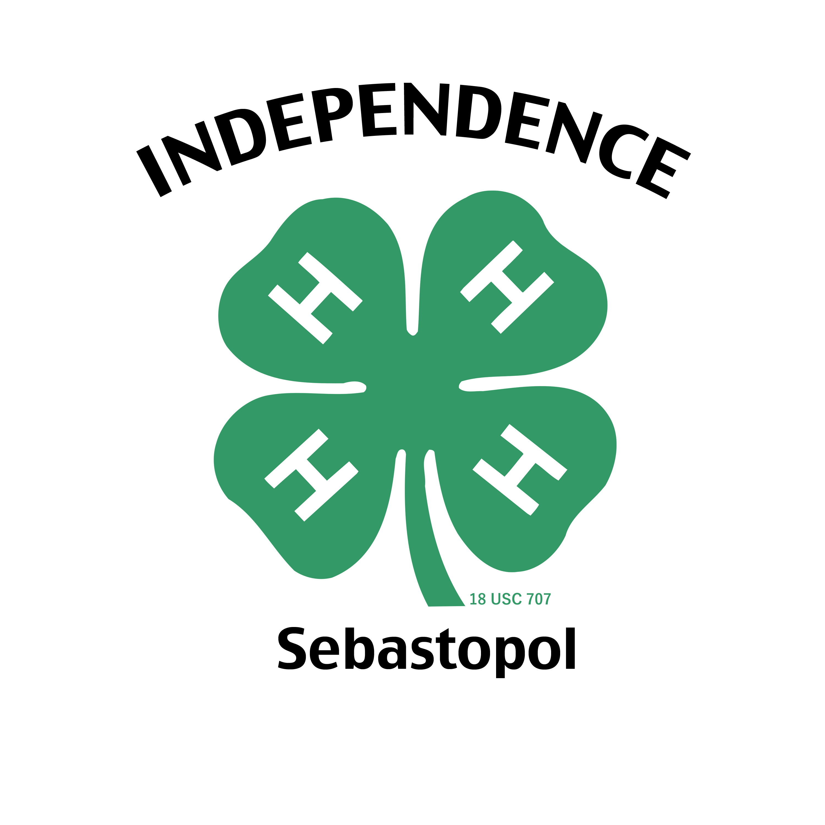

**Independence 4-H**

**Club Wear Order Form**

|  |  |
| --- | --- |
| Parent Name: | Parent phone: |
| Member Name: | Parent email: |
| **Order Information:** |  |
| **T-shirt short sleeve**: (circle one) $10  Youth Sizes: YS YM YL  Adult Sizes: AS AM AL AXL | T-shirt color: (circle one)  White Grey  Black |
| **T-shirt long sleeve**: (circle one) $13  Youth Sizes: YS YM YL  Adult Sizes: AS AM AL AXL | T-shirt color: (circle one)  White Grey  Black |
| **T-shirt Ladies Vneck**: (circle one) $12  Adult Sizes: AS AM AL AXL | T-shirt color: (circle one)  White Grey  Black |
| **Sweatshirt Hoodie**: (circle one) $25  Youth Sizes: YS YM YL  Adult Sizes: AS AM AL AXL | Sweatshirt color: (circle one)  White Grey  Black |
| **Sweatshirt Crewneck**:(circle one) $20  Youth Sizes: YS YM YL  Adult Sizes: AS AM AL AXL | Sweatshirt color: (circle one)  White Grey  Black |
| Tie Green $16.00 Scarf Green $18.00  Clip-on ( )  or  Traditional ( ) | Cap Green $22.00    Size: (circle one) S M L XL  (21 ½”, 22”, 22 ½” , 23 ½”) |
| Add $2 for XXL size |  |
| Date of order received:  Date payment received:  Payment method:  Cash $ Check #  **\*Prices include taxes and shipping charges** | Notes: |